Langchain Advanced:

Model Integration:

Create the model: We use chatopenAi and pick a model. Gpt-40-mini is a fast, low cost model that’s great for learning.

Pip install langchain-anthropic

Pip install langchain-openai

Pip install langchain-ollama

Pip install langchain-google-genai

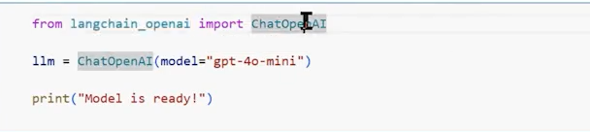
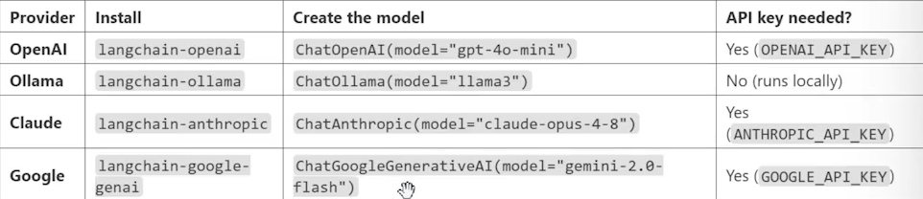
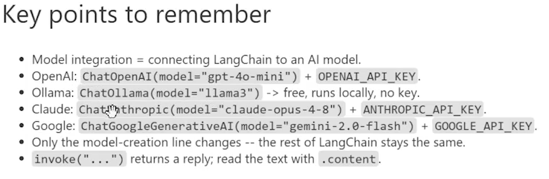

Messages:

System Message, Human Message & AI Message.

Gaurdrail - Basic:

- Input Guardrial & Output Guardrial
Nemo Guardrial (Nvedia) / llama Gaurdrial (Meta)

Evaluation Basic:

DeepEval

How to build a basic Gen AI Application:

- Langchain framework
- RAG Pipeline (Document Loader, Text Splitter, Embedding, Vector store)

Data Source
- Structured Data (Tables, CSV & Excel)
- Semi Structured Data (Json, XML, Text)
- Unstructure Data (pdf, Audio, docx, video)

RAG System Flow:
